
Introduction to Data Analysis Using Excel
Student Workbook and Evaluation
Part II
Prepared By: Said Fawzy
Manger of Information Center - Tendering Department
Arab Contractors

الاسم
الرقم الثابت
الشركة
الوظيفة

Name
ID
Company
Position

Module 4 |  | Module 5 |  | Module 6 |  | Module 7 |  | Module 8 |  | Total | %
Q | L | Q | L | Q | L | Q | L | Q | L | 60 | 100
7 | 9 | 5 | 6 | 10 | 7 | 3 | 5 | 2 | 7 | 60 | 100

Module | 04 |  | Quiz | 4
 |  | Dashboard
Files Used |  | SalesForCourse_quizz_table.xlsx | Grade (7)

Question 1
Using the data provided, create a pivot with “Country” as rows, “Product Category” as columns, and “Revenue” as values. Slice months by “April.” What does the grand total for revenue (2,200,490) represent? (1) ( )
- Total revenue for April 2015.
- Total revenue for April 2016.
- Total revenue for either 2015 or 2016 depends on which series of data appears first in the data.
- Total combined revenue for April 2015 and 2016.

Question 2
Which objects can be sliced by slicers? Choose 3 that apply. (3) ( )
- Ranges.
- Pivot Charts.
- Pivot Tables.
- Tables.

Question 3
When would you use both a slicer and a filter based on the same field? (1) ( )
- Never. Using slicers and filters at the same time might contradict therefore it is not recommended.
- When you want to search items in a field that contains many distinct values.
- When you want to apply filters on multiple Pivot Tables.
- When you want to search items and apply the results on multiple PivotTables

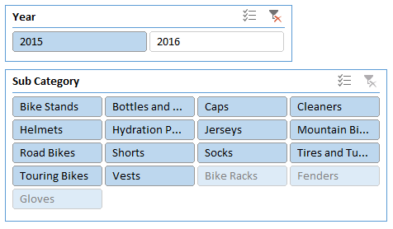
Question 4
You have the following slicers.
Why are Bike Racks, Fenders and Gloves at the bottom of the Sub Category slicer in a lighter color? (1) ( )
- They contain less rows then the others across both years.
- During 2015, there were fewer sales in these categories than in others.
- During 2015, there were no sales for these subcategories.
- During 2015, the total revenue for these sub categories was negative.

Question 5
You have the following slicers.
What will happen if you click "Bike Racks"? (1) ( )
- All Pivot Tables connected to subcategory slicer will be blank.
- All Pivot Tables connected to both year and subcategory slicers will be blank.
- This subcategory cannot be selected.
- 2016 will become selected in the year slicer above.
Module | 04 |  | Lab | 4A
 |  | Dashboard
Files Used |  | Lab4AStart .xlsx | Grade (5)

Scenario:
You have created several pivot tables and pivot charts for Lucy. So far everything has been well received by her. However, she would like to have easier ways to slice and dice the reports and charts herself. You sat down with Lucy, and come up with several different ways that Lucy could slice the data:
- Year
- Country
- Customer Gender
- Age Group
- Product Category
- Sub Category
- Frame size

Step 1:
Start by adding a new sheet named Dashboard. Then move (Cut and Paste) the four charts that you have to that sheet. Arrange the charts as appropriate.
Hint: The Snap to Grid option located at the Align Object on the Page Layout tab might be useful.
For easy reference, let's give the charts titles if they don't have any, or rename them as appropriate. Name the four charts as follows:
- Yearly Sales by Country
- Yearly Sales by Category
- Sales by Frame Size
- Sales by Age Group
Hint: To add a chart title, select the chart, then on the Design tab, select Add Chart Element.

Step 2:
You can now add slicers to the sheet. Select the Yearly Sales by Country chart, and add seven slicers corresponding to Year, Country, Customer Gender, Age Group, Product Category, Sub Category and Frame Size. Arrange the slicers as appropriate.

Step 3 :
The next thing you need to do is to connect these slicers to the charts. Let's do this chart by chart.
Hint: The Filter Connections option is available on the chart Analyze tab.
- Connect the Yearly Sales by Country chart to all slicers, except the Year slicer. In another words, disconnect the Year slicer from the Yearly Sales by Country
- Connect the Yearly Sales by Category chart to the Age Group, Country, Customer Gender, and Frame Size slicers.
- Connect the Sales by Frame Size chart to all slicers, except the Frame Size slicer.
- Connect the Sales by Age Group chart to all slicers, except the Age Group.
For niceties, you can clear the Gridlines on the Dashboard,
Hint: The Gridlines option is available on the View tab.
Once you've done the above, you're ready to present the dashboard to Lucy.

Question 1
A quick glance on the Yearly Sales by Country shows that Australia has an unusual trend compared to the other countries. Which year does Australia have the least sales? (1) ( )
- 2011
- 2012
- 2013.
- 2014

Step 4:
Create an additional pivot chart to show Sales by Country using Pie chart. Show percentages for each slice of the pie and connect the chart to all the slicers, except the Country slicer. Overall, Australia commands 25% of the company's total sales. But in some of the years, this proportion changes.

Question 2
What is the percentage of Australia sales (of total sales) in the year that it has the least sales (previous question)? (1) ( )
- 13%.
- 16%.
- 20%.
- 28%.

Question 3
Let's filter the charts by Australia using the Country slicer. What might be the cause of this trend? (1) ( )
- The introduction of new line of products in Accessories and Clothing.
- The sharp fluctuations of bicycle sales..
- The sharp fluctuations of Accessories sales..
- The sharp fluctuations of Clothing sales.

Step 5:
Based on your hypothesis (previous question), create an additional pivot chart to show Sales by Category using Pie chart. Show percentages for each slice of the pie and connect the chart to all the slicers, except the Category slicer. Filter the charts by Australia using the country slicer and play around with the Year filter. Notice for different years, the changes in composition of Australia sales by Category.

Question 4
For all the years that has all the three categories, which year does the Bikes has the least proportion? (1) ( )
- 2013.
- 2014.
- 2015.
- 2016.

Question 5
What is the percentage of Bikes sales (of total sales) in that year? (1) ( )
  - 48%.
  - 59%.
  - 66%.
  - 75%.

Module | 04 |  | Lab | 4B
 |  | Dashboard
Files Used |  | Lab4AStart .xlsx | Grade (4)

Step 1:
Create an additional pivot chart to show Sales by Customer Gender using Pie chart. Show percentages for each slice of the pie and connect the chart to all the slicers, except the Customer Gender slicer.
Overall, it is split evenly with 51%:49% of Male to Female ratio.

Question 1

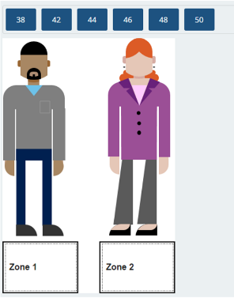
PROBLEM (2) ( )
Which Bike's frame size is more popular for each Gender? Place the Frame size into the appropriate box.
Hint: Clear any existing filter, then Use the Customer Gender filter and review the Sales by Frame Size chart.

Step 2:
What about Customer Gender vs age group? Right now the Sales by Age Group chart does not differentiate by Gender. Modify this chart to be a Column chart. Show the Customer Gender side-by-side for each age group. Ensure that the chart is connected to all slicers. Last but not least, sort the Age Group appropriately.
Hint: Clear any existing filter, place Customer Gender as Legend and create Custom List to sort the Age Group.

Question 2
In Australia, which Age Group has more sales revenue to females than to males? (Select two that apply) ( 2 ) ( )
- Youth (<25).
- Young Adults (25-34).
- Adults (35-64).
- Seniors (64+).

Module | 05 |  | Quiz | 5
 |  | Profitability Analysis
Files Used |  |  | Grade (5)

Question 1
You have a sales table that contains “Quantity,” “Unit Price,” and “Unit Cost.” How would you add the following calculations to be used in a PivotTable?
Total Cost (1) ( )
- Add a Pivot Table calculated field (Total Cost = Unit Cost * Quantity).
- Add a calculated column in the table (Total Cost = Unit Cost * Quantity).
Total Revenue (1) ( )
- Add a Pivot Table calculated field (Total Revenue = Unit Price * Quantity).
- Add a calculated column in the table (Total Revenue = Unit Price * Quantity).
Total Profit (1) ( )
- Add a Pivot Table calculated field (Total Profit = Revenue - Cost).
- Add a calculated column in the table (Total Profit = Revenue - Cost).

Profit Margin (1) ( )
- Add a PivotTable calculated field: Profit Margin = (Revenue - Cost) / Revenue.
- Add a calculated column in the table: Profit Margin = (Revenue - Cost) / Revenue.

Question 2
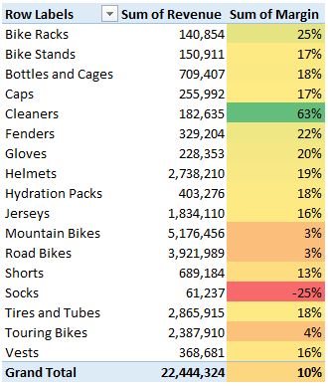
Conditional formatting (Green – Yellow – Red Color Scale) was applied on the above PivotTable. What can you do in order to improve usability of the formatting? (1) ( )
- Replace Green – Yellow – Red Color Scale with Blue – White – Red Color Scale.
- Use Icon Set instead of Color Scale.
- Modify the percentiles for maximum and minimum values.
- Use Data Bars instead of Color Scale.

Module | 05 |  | Lab | 5
 |  | Profitability Analysis
Files Used |  | Lab5Start.xlsx | Grade (6)

Scenario
Lucy was impressed with the dashboard you created.
With the dashboard, she is able to narrow down her interest. Specifically, she is interested with the sales in Australia. She would like to perform simple profitability analysis on the product category and sub-category, for specific year. Furthermore, she wants to have the option of going deeper to product level.

Step 1:
Start by adding a new sheet named Details. Add a pivot table that shows Order Quantity, Revenue, and Profit by Product Category. Add the Year and Country field to the filter list.
Add the Sub Category field to the rows of the pivot table. Make sure the rows are fully expanded. Now you have quite a few numerical data shown in the pivot table, which might not be as easy to analyze as before. Apply Data bars conditional formatting to the Order Quantity, Revenue and Profit column on Sub Category level. Use blue, green, and yellow respectively.
Filter the pivot table for Australia and 2016, and answer the following questions.

Question 1
Which Sub Category sold the most quantity? (1) ( )
  - Tires and Tubes
  - Road Bikes
  - Helmets
  - Bottles and Cages

Question 2
Which Sub Category has the most revenue? (1) ( )
  - Tires and Tubes
  - Road Bikes
  - Helmets
  - Bottles and Cages

Step 2:
Now, add a calculated field to your pivot table, name the field Margin with the value derived from the Profit and Revenue column. Format the field as percentage with two decimal places.
HINT: Margin = Profit / Revenue

Question 3
What is the total margin for Australia in the year 2016? (1) ( )
  - 38.96%
  - 26.26%
  - 33.74%
  - 20.41%

Question 4
Using the same filters, which category has the lowest margin? (1) ( )
  - Accessories
  - Bikes
  - Clothing
  - Miscellaneous

Step 3:
Now, apply Color scales conditional formatting to Margin for the Sub Category level.

Question 5
Which Sub Category has the lowest margin? (1) ( )
  - Caps
  - Road Bikes
  - Mountain Bikes
  - Jerseys

Step 4:
Let's dig a little deeper. Add the Product field to the Rows, under Sub Category. Ensure that the Year and Country filter still select 2016 and Australia respectively. Apply Color scales conditional formatting only to the cells showing the margin for the Product.

Question 6
Which product has the least margin? (1) ( )
  - AWC Logo Cap
  - Road-350-W Yellow, 44
  - Mountain-500 Silver, 42
  - Short-Sleeve Classic Jersey, M

Module | 06 |  | Quiz | 6
 |  | Comparing Year Over Year in Pivot Table
Files Used |  |  | Grade (10)

Question 1
What is the main advantage of referencing cells in a Pivot Table with the GetPivotData() function rather than by regular cell reference? (1) ( )
- The function returns a value that is always filtered by all slicers.
- It returns the same values even if the layout of the data changes.
- GetPivotData() is being refreshed automatically.
- GetPivotData() will display the values even if they are removed from the PivotTable

Question 2
What are the disadvantages of referencing cells in a Pivot Table with the GetPivotData() function and not by regular cell reference? Choose three that apply. (3) ( )
- The function is not adjusted when it is dragged across cells.
- It is very complicated to edit the function.
- It is very complicated to write the function manually.
- The function returns different values when the layout of the data changes

Question 3
What are the advantages of creating aggregates using SUMIFS() rather than using a Pivot Table? Choose three that apply. (3) ( )
- SUMIFS() formulas can be arranged in flexible formats in the grid.
- SUMIFS() formulas' comparison operators are not restricted to equality.
- SUMIFS() formulas are faster to calculate than creating aggregates.
- SUMIFS() formulas do not require refreshes to reflect changes in the data.

Question 4
What are the disadvantages of creating aggregates using SUMIFS() rather than using a Pivot Table? Choose three that apply. (3) ( )
- A range with SUMIFS formulas is much more difficult to change if you need to include more or fewer fields.
- SUMIFS() formulas cannot be based on an Excel table.
- Pivot Tables shrink and expand dynamically based on the data.
- On a report based on SUMIFS() formulas, you are unable to implement simple drill downs and drill ups.
Module | 06 |  | Lab | 6
 |  | Profitability Analysis
Files Used |  | Lab6Start.xlsx | Grade (7)

Scenario:
Lucy seems intrigued your presentation on Australia's sales.
Now, she wants to review the sales difference (growth) for Product Category and Sub Category between year 2015 and 2016. She wants to be able to filter the report by all the options available, including Customer Gender and Age Group.

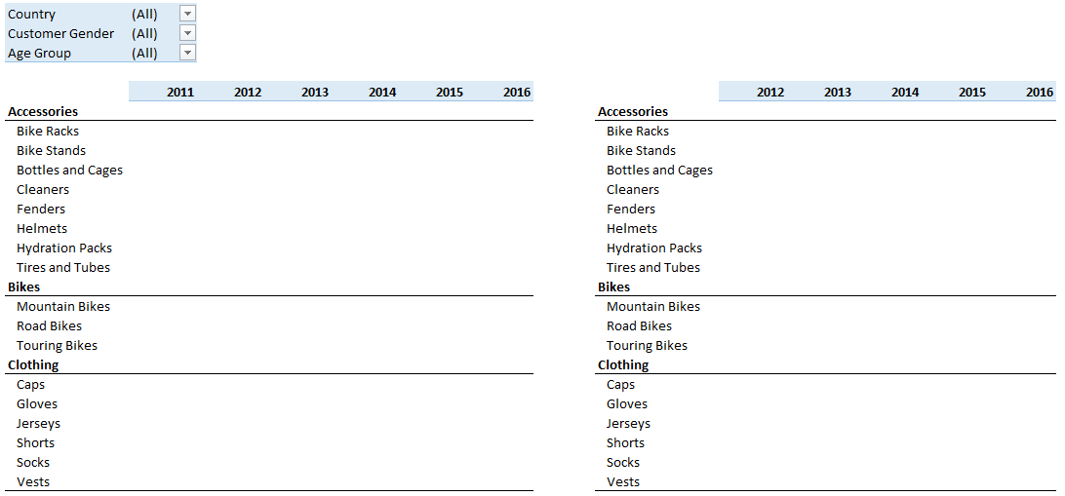
You will create two reports. One with the sales for each year and the other with the % Change in Revenue from Year to Year. Each report is a cross-tabular format with Product Categories and Sub categories on the rows and Year on the columns, with Sum of Revenue as the aggregate data. When you are done, neither report will be based on a Pivot Table. However, you will enable a Pivot Table filter to allow the selection of Country, Customer Gender, and Age Group for these reports. Visually, you would like to have something like this:

Step 1:
Let's start by adding a new sheet named Growth. Starting in cell B1, add a new pivot table using SalesTable as the source with Country, Customer Gender, and Age Group as Filters, Product Category and Sub Category as Rows, Year as Columns, and Sum of Revenue as Values.

Step 2:
Now, copy the structure of the rows and columns to the cells next to the pivot table, that is, copy the Years labels in C6:H6 (excluding the Grand Total) to range L6:Q6, and the Product categories and Sub categories labels in B7:B26 (excluding the Grand Total) to range K7:K26. Highlight and copy range B6:H26, place your cursor in cell K6, right click and from the Paste Options, select Formatting (R).
Alternatively, you can select B6:H26, place your cursor in cell K6, right click and from the Paste Options, select Values (V) and then, once again right click in cell K6, and from the Paste Options, select Formatting (R). After which, delete the data area.

Step 3
Populate the data area of the newly created cross tabular structure using SUMIFS() function.
Assuming that you have:
- K7: Product Category eg "Accessories"
- Q6: Year eg. "2016"
- C1: Country Filter
- C2: Customer Gender Filter
- C3: Age Group Filter
Then, the cell that corresponds to Year 2016 for the Product Category Accessories would have the following formula
=SUMIFS(SalesTable[Revenue],
SalesTable[Product Category],$K7,
SalesTable[Year],Q$6,
SalesTable[Country],IF($C$1="(All)","*",$C$1),
SalesTable[Customer Gender],IF($C$2="(All)","*",$C$2),
SalesTable[Age Group],IF($C$3="(All)","*",$C$3))

Step 4:
Now, copy this formula (using Ctrl C keyboard combination) and paste it (using Ctrl V keyboard combination) into the other Years and Product Category cells for all three categories (Accessories, Bikes, Clothing). When you are done, your calculated values in cells L7:Q7, L16:Q16 and L20:Q20 should match their respective pivot table values.
In addition, assuming that you have:
- K8: Sub Category eg "Bike Racks"
- Q6: Year eg. "2016"
- C1: Country Filter
- C2: Customer Gender Filter
- C3: Age Group Filter
Then, the cell that corresponds to Year 2016 for the Sub Category Bike Racks would have the following formula
=SUMIFS(SalesTable[Revenue],
SalesTable[Sub Category],$K8,
SalesTable[Year],Q$6,
SalesTable[Country],IF($C$1="(All)","*",$C$1),
SalesTable[Customer Gender],IF($C$2="(All)","*",$C$2),
SalesTable[Age Group],IF($C$3="(All)","*",$C$3))
Now, copy this formula (using Ctrl C keyboard combination) and paste it (using Ctrl V keyboard combination) into the other Years and Sub Category cells. When you are done, your calculated values in these cells should match their respective pivot table values.
Once your table is populated, remove the fields from the Rows, Columns, and Values of the Pivot table, so that only the filters remains. Align the filters with your cross tabular report and add sparklines (to show the series high point) next to the column containing the last year of data.
When you are done with the first cross tabular report, create another one with the same structure next to it (excluding the 2011 column). This time, for % Change in Revenue, which is essentially the difference between the two years, divided by the previous year.
For example, one formula could be:
=IF(C7<>0,(D7-C7)/C7,0)

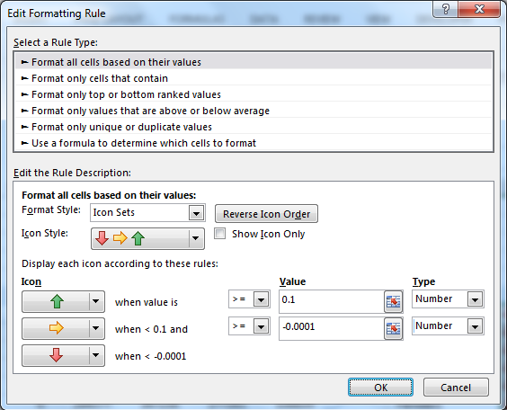
Step 5:
Present the data as percentage without decimal places. Apply an Icon Sets conditional formatting to differentiate positive and negative growth. Edit your conditional formatting icon set rules to display the icons similar to the rule below:

When you're done, you should have something like this (the below is just an example, your values may not necessarily match):
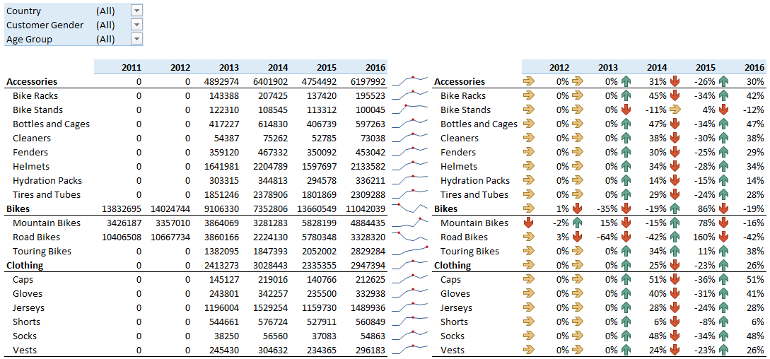

Question 1
Without applying any filter, which year does the Accessories category have negative growth? (1) ( )
- 2013
- 2014
- 2015
- 2016

Question 2
Filter the report for Youth Age Group. Which two years do the Accessories category have negative growth? (2) ( )
- 2013
- 2014
- 2015
- 2016

Question 3
Without applying any filter, which two years do the Bikes category have negative growth? (2) ( )
- 2013
- 2014
- 2015
- 2016

Question 4
Filter the report for Australia. Which year do the Bikes category have the highest growth? (1) ( )
- 2013
- 2014
- 2015
- 2016

Question 5
Keep the Australia filter. In the year that Bikes sales have the highest growth (previous question), which Subcategory of Bikes has the highest growth? (1) ( )
- Mountain Bikes
- Road Bikes
- Touring Bikes
- City Bikes
Module | 07 |  | Quiz | 7
 |  | Reporting Hierarchal Data
Files Used |  |  | Grade (3)
Question 1
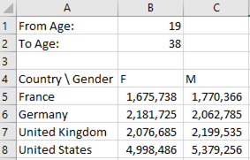
How would you modify the following formula to include age ranges in the following report? (1) ( )
=SUMIFS(SalesTable[Revenue],SalesTable[Customer Gender],B$4,SalesTable[Country],$A5)

- =SUMIFS(SalesTable[Revenue],SalesTable[Customer Gender],B$4,SalesTable[Country],$A5,SalesTable[Customer Age],">=$B$1",SalesTable[Customer Age],"<=$B$2")

- =SUMIFS(SalesTable[Revenue],SalesTable[Customer Gender],B$4,SalesTable[Country],$A5,SalesTable[Customer Age], AND(SalesTable[Customer Age] >=$B$1,SalesTable[Customer Age]<=$B$2 ))

- =SUMIFS(SalesTable[Revenue],SalesTable[Customer Gender],B$4,SalesTable[Country],$A5,SalesTable[Customer Age],">="&$B$1,SalesTable[Customer Age],"<="&$B$2)

- =SUMIFS(SalesTable[Revenue],SalesTable[Customer Gender],B$4,SalesTable[Country],$A5,SalesTable[Customer Age],">="&$B$1 AND SalesTable[Customer Age],"<="&$B$2)

Question 2
What is the main purpose of using the Treemap and Sunburst charts to display data? Select the best answer. (1) ( )
- To compare values between elements.
- To use colors to represent values.
- To show the relative size at different levels of a hierarchy.
- To show trend in data.

Question 3
You want to create a SUMIFS() formula that references a specific cell in your spreadsheet as you apply it to a range of data containing multiple columns. What should you do? (1) ( )
- Use Name Manager, and use the names in your formula.
- Use referenced table columns by name.
- Write a separate formula for each column, and then copy/paste the formula to all rows.
- Use a mix of absolute and relative reference in your formula.

Module | 07 |  | Lab | 7
 |  | Profitability Analysis
Files Used |  | Lab7Start.xlsx | Grade (5)

Scenario
Upon reviewing the growth report you created, Lucy asked for a report that shows composition of Product Categories and Sub Categories based on certain filters, including Year, Country, Customer Gender, and Age Group.
Specifically, Lucy wants to see the report visualized using a hierarchical chart.

Step 1:
Let's add another sheet to the workbook and name it Composition.
Start by adding a new pivot table with Year, Country, Customer Gender, and Age Group as Filters, Product Category and Sub Category as Rows, and Sum of Revenue as Values.
Format the pivot table to show in Tabular form, do not show subtotals and grand totals, and repeat all item labels.

Step 2:
Now, copy the structure of the rows and columns to the cells next to the pivot table, that is the Product categories and Sub categories as Rows. Delete the data area for now.
Populate the data area of the newly created cross tabular structure using SUMIFS() function.
Assuming that you have:
- F7: Product Category eg. "Accessories"
- G7: Sub Category eg. "Bike Racks"
- C1: Year filter
- C2: Country Filter
- C3: Customer Gender Filter
- C4: Age Group Filter
Then, the cell that corresponds the Product Category Accessories and Sub Category Bike Racks would have the following formula:
=SUMIFS(SalesTable[Revenue],
SalesTable[Product Category],$F7,
SalesTable[Sub Category],$G7,
SalesTable[Year],IF($C$1="(All)",">0",$C$1),
SalesTable[Country],IF($C$2="(All)","*",$C$2),
SalesTable[Customer Gender],IF($C$3="(All)","*",$C$3),
SalesTable[Age Group],IF($C$4="(All)","*",$C$4))

Step 3:
Once your table is populated, remove the fields from the Rows, Columns, and Values of the Pivot table, so that only the filters remains. Align the filters with your cross tabular report. Create a treemap or sunburst chart based on the data in the cross tabular report. Name the chart "Sales Composition".

Question 1
Explore the sales composition of Bikes category for each Age Group. Which Age Group does the composition (rank of sales) differ than the rest? (1) ( )
- Youth
- Young Adult
- Adults
- Seniors
- The composition are the same across Age Group

Question 2
Now explore the sales composition of Bikes category for each Age Group, for the Male customers. Which Age Group does the composition differ than the rest? (1) ( )
- Youth
- Young Adult
- Adults
- Seniors
- The composition are the same across Age Group

Question 3

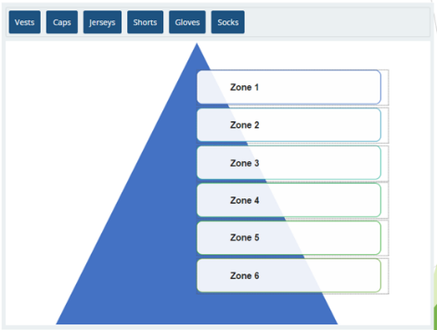
PROBLEM (1) ( )
Clear all filters. Now, filter for the year 2016 and Germany. Rank the sales from the highest to lowest for the Clothing category.
HINT: You might want to specify the data for the charts only for the Clothing category.

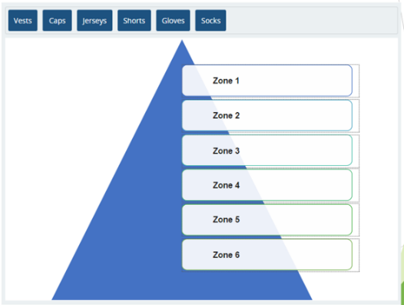
Question 4

PROBLEM (1) ( )
Keep the filter settings and add filter by Male customers. Rank the sales from the highest to lowest for the Clothing category

Question 5

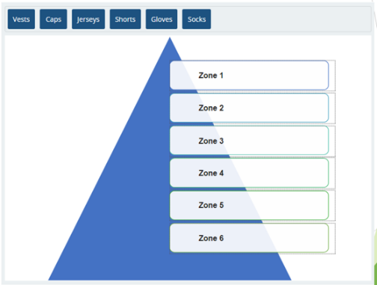
PROBLEM (1) ( )
Keep the filter settings and add filter by Youth Age Group. Rank the sales from the highest to lowest for the Clothing category.

Module | 08 |  | Quiz | 8
 |  | Multicable Pivot table
Files Used |  |  | Grade (2)

Question 1
You want combine data in two ranges/tables in a single pivot. What should you do? Choose two that apply. (2) ( )
- Click ‘More Tables…’ from the pivot field list, and create relationships between the different ranges.
- Connect the two sources of data using the same slicer.
- Copy the second range, append to the first, and define the pivot on the combined range.
- Combine the different ranges into one range using VLOOKUP formulas.

Module | 08 |  | Lab | 8
 |  | Profitability Analysis
Files Used |  | Lab8Start.xlsx. And Demographics.mdb or (Customer_demographics.txt) | Grade (7)

Scenario
Lastly, Lucy wants to have more information about the customer demographics in addition to the already available age and gender. Since your data has Customer ID for each row, you can "connect" these rows with your customer demographics database. Your customer demographics is stored in an Access database.

Step 1:
Let's bring the customer database into your Excel.
1. From a new worksheet, go to the Data tab and on the Get &Transform Data group, select the Database From Microsoft Access option. This will bring up the Select Data Source dialog box.
2. Navigate to where you saved the Demographics.mdb file, select it and click on the Import button.
3. From the Navigator dialog box, selected Customer_dimographhic Table
4. Press Load.
5- Your import should result in 18,484 rows (plus the header) and seven columns of data.
6. Now, add the MaritalStatus and TotalChildren fields from the Customer_demographic table as Rows and Order Quantity from the SalesTable as Values. In addition, add the Product Category as filters.

Question 1
For those customers who bought bikes, what are the top three (bought the most quantity) customer profiles (marital status and number of children)? (3) ( )
  - Single without child
  - Single with one child
  - Married with one child
  - Married with two children

Step 2:
Now, remove the MaritalStatus and TotalChildren fields from the Rows and replace them with the YearlyIncome field from the Customer_demographic table.

Question 2

PROBLEM (1) ( )
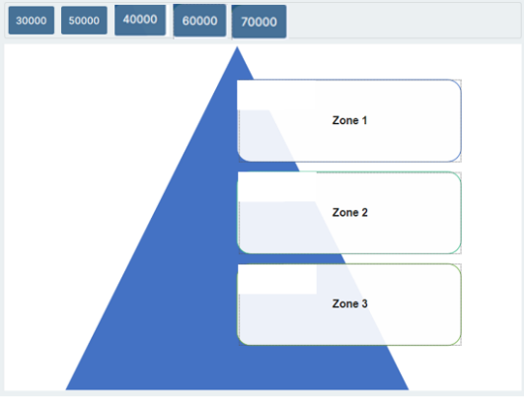
For those customers who bought bikes, what are the top three (bought the most quantity) income brackets? (Rank from highest to Lowest)
HINT: Sort the YearlyIncome by Sum of Order Quantity in Descending order.

Step 3:
Now, remove the YearlyIncome field from the Rows and replace it with the EnglishEducation field from the Customer_demographic table.

Question 3
For those customers who bought bikes, what are the top two (bought the most quantity) education levels? (2) ( )
- High School
- Partial College
- Bachelors
- Graduate Degree

Step 4:
Lastly, replace the Rows with the HouseOwnerFlag field from the Customer_demographics table. Format the Sum of Order Quantity to show as Percentage of Grand Total with two decimal places.
Lastly, remove the EnglishEducation field from the Rows and replace it with the HouseOwnerFlag field from the Customer_demographics table. Format the Sum of Order Quantity to show as Percentage of Grand Total with two decimal places.

Question 4
What is the percentage of the customers who bought Bikes and are house owners? (1) ( )
  - 31.28%
  - 38.72%
  - 61.28%
  - 68.72%

